Notes on statistics:
- We use sample instead of population due to feasibility issues of collecting and catering data of whole population.
- In case sample size increases, the sample measures come closer to population measures.
- We check the distribution of the data, so that we can know how to convert them to a standard scale, in order to increase accuracy. For e.g. in case, we know our value follow log ND, then we can take log and standard scale them. This will be used in EDA
- Covariance tells us the relation between random variables. However, to know the strength of relation we use correlation coefficients.
- in case of outliers, use median or mode to handle missing values. Else we use mean
- It is important to know what type of random variable our data column belongs to.
- Discrete variable is whole number and not -ve.
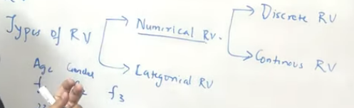
- The central limit theorem states that if you have a population with mean μ and standard deviation σ and take sufficiently large random samples from the population with replacement , then the distribution of the sample means will be approximately normally distributed.
- Impact of central limit theorem: https://machinelearningmastery.com/a-gentle-introduction-to-the-central-limit-theorem-for-machine-learning/
https://towardsdatascience.com/why-the-central-limit-theorem-in-data-science-be8997b95f3
- Covariance is needed so that we can derive relations between random variables in order to do predictions. Covariance tells us the direction of relationship. Correlation coefficient helps us to get the strength or a numeric value of this relationship.
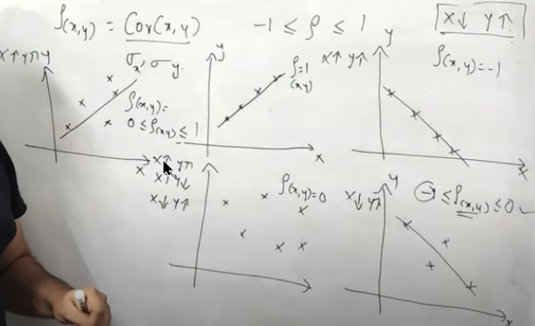
- This technique is used in feature selection to select features which are highly correlated and so on etc.
- Spearman correlation makes use of rank of x, y instead of variance. Pearson correlation only focuses on the linear aspect of the relations and hence, spearman is more robust to outliers and hence, given accurate results regarding the correlation, hence mostly used.
- To identify outliers, we can use z-score or IQR.
- Z-score works by checking that which values lie outside the 3rd std. deviation, and hence those are termed as outliers.
- For IQR, we simply find the lower and upper bound of the IQR and values outside this IQR will be outliers.
- Standardization transforms values to follow a similar scale with mean 0 and std 1. Assuming the data follow ND then it will give ND. while normalization transforms values between 0 and 1.
- For most machine learning algorithms that make use of Euclidean distances or some sort of distance such as Kmeans, KNN, Logistic regression, gradient descent, linear regression we make use of standard scaler. Standardization is more suited than normalization in such cases.
- Decision trees, random forest and boosting / bagging algorithm don’t need standardization.
- For some neural network algorithms such as CNNs, we use normalization mostly.

Statistics Playlists:
- https://www.youtube.com/c/BrandonFoltz/playlists
- https://www.youtube.com/watch?v=uhxtUt_-GyM&list=PL1328115D3D8A2566&ab_channel=KhanAcademy

